Capture cinematic Full HD videos

[Watch Video](https://www.kingston.com/en/video/play?videoId=LvLTi90SF2U_74fCLG7rirjegCfyZXBD1MpLMU9SJdwMSY99hrO8yPkSRkG9_HIcMRckXWaf6IMOCMQVfk4mJg2&start=0&autoPlay=False&chromeless=False&captionOption=No)

SDS2

* [Intro](https://www.kingston.com/en/memory-cards/canvas-select-plus-sd-card#product-features)
* [Product Comparison](https://www.kingston.com/en/memory-cards/canvas-select-plus-sd-card#comparison-chart-1)
* [Specifications](https://www.kingston.com/en/memory-cards/canvas-select-plus-sd-card#specifications)
* [Resources](https://www.kingston.com/en/memory-cards/canvas-select-plus-sd-card#links)
* [Datasheet](https://www.kingston.com/datasheets/sds2_us.pdf)

[**Buy**](https://www.kingston.com/en/memory-cards/canvas-select-plus-sd-card#atc)

Canvas Select Plus SD CardFor Full HD 1080p Video Cameras

Kingston’s Canvas Select Plus SD card is designed with exceptional performance, speed, and durability for heavy workloads such as transferring and developing high-resolution photos or capturing and editing full HD videos. It can reach Class 10 UHS-I speeds up to 100MB/s1 for easy storage and quick transfers along with a Video Class 30 interface that can record cinematic Full HD videos2. The Canvas Select Plus SD card is built to perform in the harshest environments and conditions so you can take it anywhere knowing your files, photos, and videos are protected. Available in multiple capacities up to 512GB3 and with a lifetime warranty.

* Class 10 UHS-I speeds up to 100MB/s1
* Capture images and videos in Full HD (1080p)
* Capacities up to 512GB3
* Durable
* Lifetime Warranty

Key Features



Faster speeds

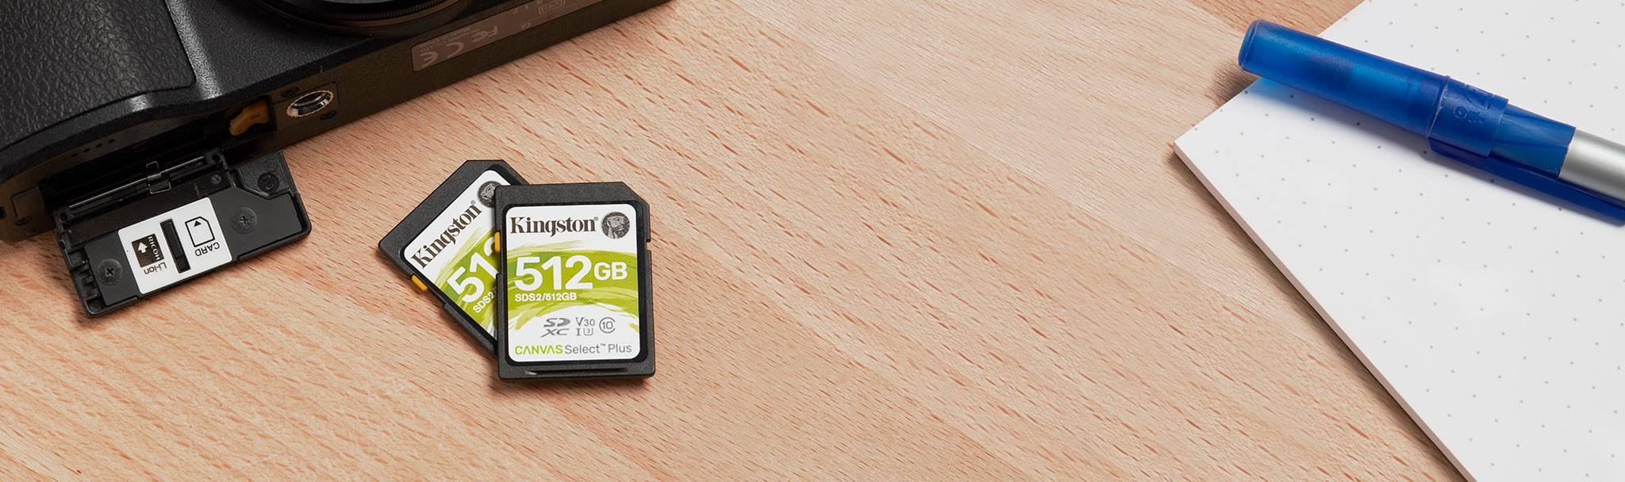

Capture images and videos in Full HD (1080p)

Compare SD Cards

SDS2

SDG3

SDR2

SDR2V6

SDIT











Name

Canvas Select Plus

Canvas Go! Plus

Canvas React Plus SD

Canvas React Plus V60 SD

Industrial SD

User

Consumer

Consumer-Enthusiast

Professional

Professional

Business/ Industrial

Capacity

64GB-512GB

64GB - 1TB

32GB-256GB

128GB-1TB

8GB-64GB

Speed

• 100MB/s Read (64GB)  
• 100MB/s Read, 85MB/s Write (128GB-512GB)

• 170MB/s Read, 70MB/s Write (64GB)  
• 170MB/s Read, 90MB/s Write (128GB-1TB)

300MB/s Read, 260MB/s Write

• 280MB/s Read, 100MB/s Write (128GB)  
• 280MB/s Read, 150MB/s Write (256GB-1TB)

Up to 100MB/s Read, 80MB/s Write

Compatibility

Yes

UHS-I, U3, V30

UHS-II, U3, V90

UHS-II, U3, V60

UHS-I Speed Class U3, V30, A1

Usage

• Point and shoot cameras  
• Full HD videos

for shooting 4K UHD video and burst-mode photography

• 8K/3D/VR Video Production  
• UHS-II Cinema Cameras  
• DSLR

• 4K Video  
• UHS-II Cinema Cameras  
• DSLR

• Designed and tested to be durable in extreme temperatures

[Learn more](https://www.kingston.com/en/memory-cards/canvas-select-plus-sd-card)

[Learn more](https://www.kingston.com/en/memory-cards/canvas-go-plus-sd-card)

[Learn more](https://www.kingston.com/en/memory-cards/canvas-react-plus-sd-card)

[Learn more](https://www.kingston.com/en/memory-cards/canvas-react-plus-sd-v60)

[Learn more](https://www.kingston.com/en/memory-cards/industrial-grade-sd-uhs-i-u3)

 Reset Chart

 Remove

 Remove

 Remove

 Remove

 Remove

Capacity

 64GB

 128GB

 256GB

 512GB

* Part Number: SDS2/64GB

[**Where to Buy**](https://www.kingston.com/en/wheretobuy)

Specifications

|  |  |
| --- | --- |
| Capacities3 | 64GB, 128GB, 256GB, 512GB |
| Standard/Class | Class 10, UHS-I, U1/V10 (64GB), U3/V30 (128GB-512GB) |
| Performance1 | 100MB/s Read (64GB) 100/85MB/s Read/Write (128GB-512GB) |
| Dimensions | 24mm x 32mm x 2.1mm |
| Format | exFAT (64GB-512GB) |
| Operating temperature | -25°C~85°C |
| Storage temperature | -40°C~85°C |
| Voltage | 3.3V |
| Warranty/support | Lifetime |